CMPS350 Web Development Fundamentals

**- Group Project -**

Phase 1: E-Commerce Platform

Spring 2024

SID: 201704728 STUDENT NAME: Dalal Nayem

SID: 202006354 STUDENT NAME: Hanan Rashid

SID: 202103964 STUDENT NAME: Maryam Alsheikh

* Course number: CMPS350
* Submission date: 30/3/2024
* Class section: **L51**
* GitHub link: <https://github.com/hanan-hr2006354/WebProject>
* DECLARATION: *We hereby certify that no part of this project or product has been copied from any other student’s work or from any other sources except where due acknowledgment is made in the project. No part of this project/product has been written/produced for us by any other person.*

Table of Contents

Entities, Repositories and Web API class diagrams 2

Documentation of the app testing 3

# Entities, Repositories and Web API class diagrams

We have two json files:

1. Users.josn to store the data of the 3 different type of **users**: customer, seller and admin.
2. Items.json to store the 4 categories of the products sold with their information.

The json files are the entities.

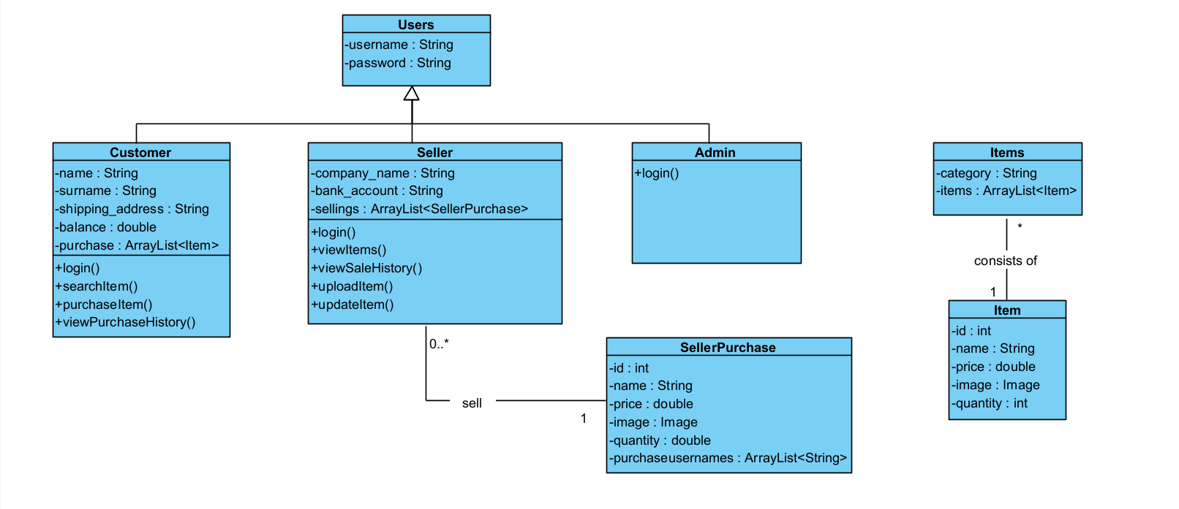

# Documentation of the app testing

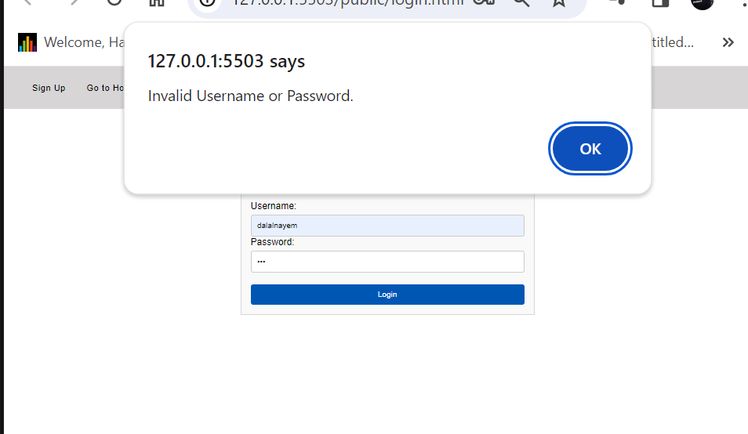Use Case 1: Login

A user cannot log in if the password or username does not match

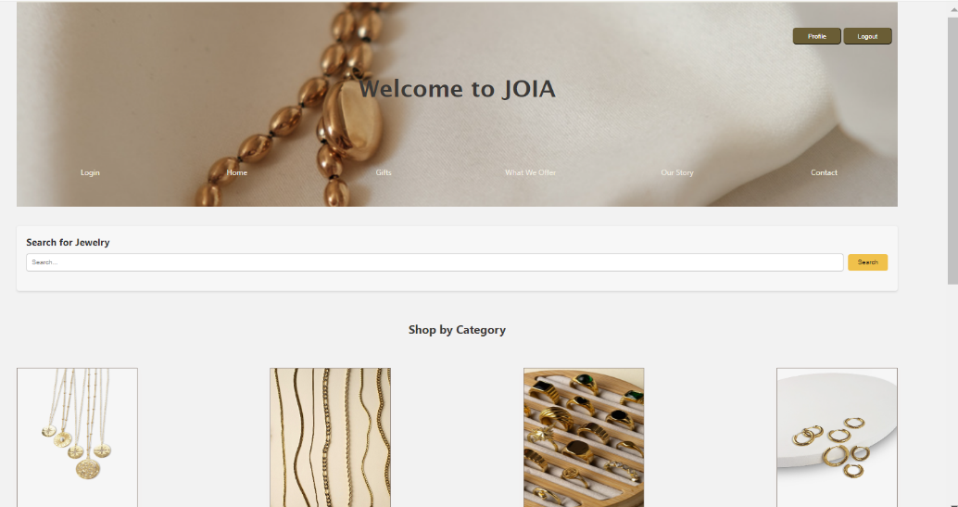

Customer successfully logged in

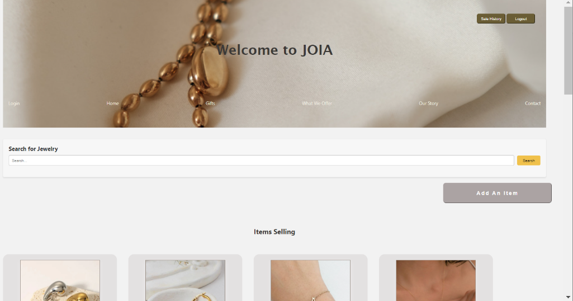

Seller successfully logged in

Use Case 2: Search available items in main page

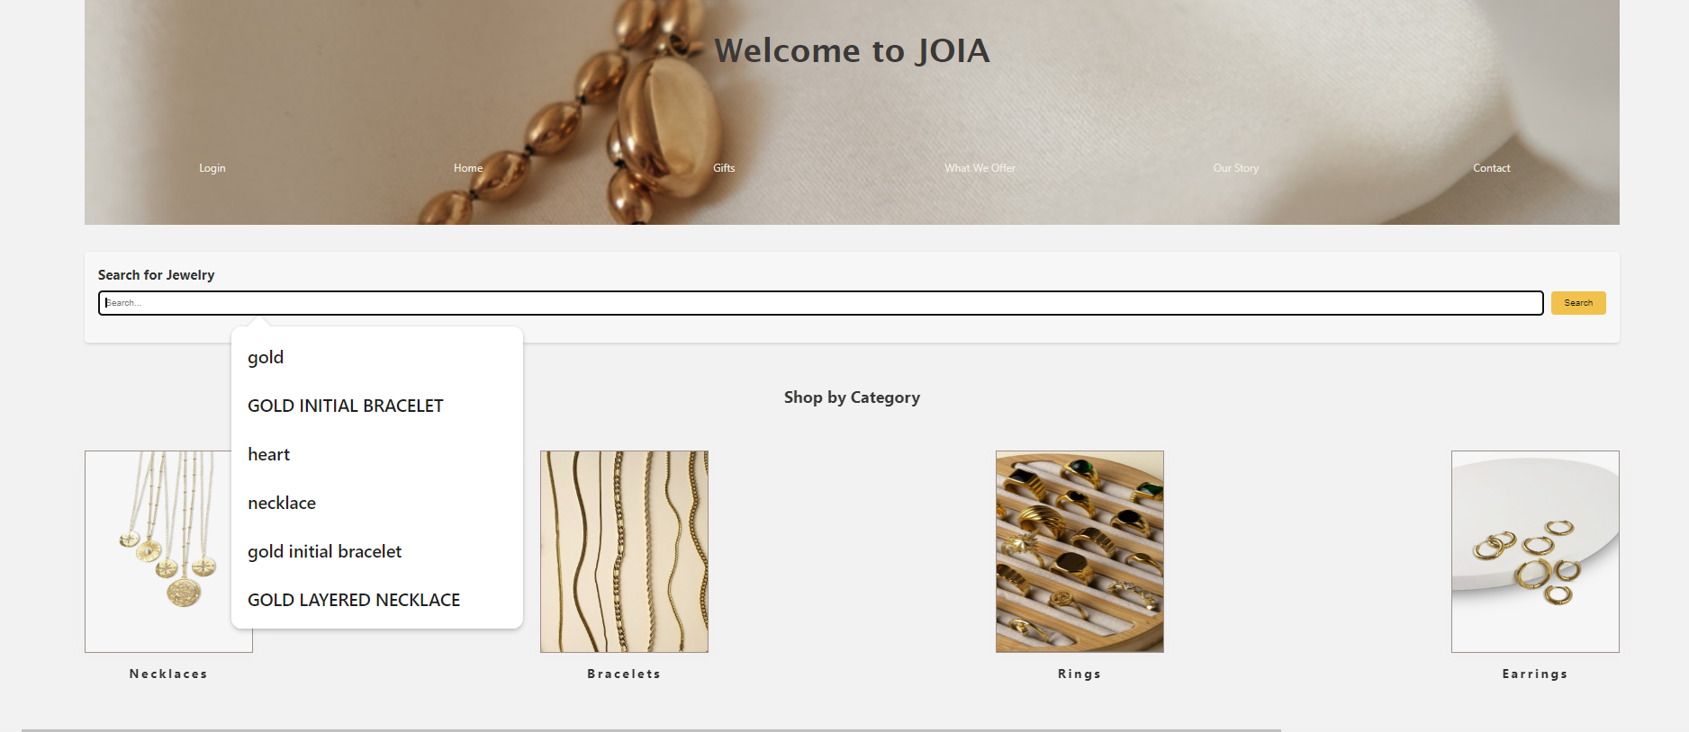

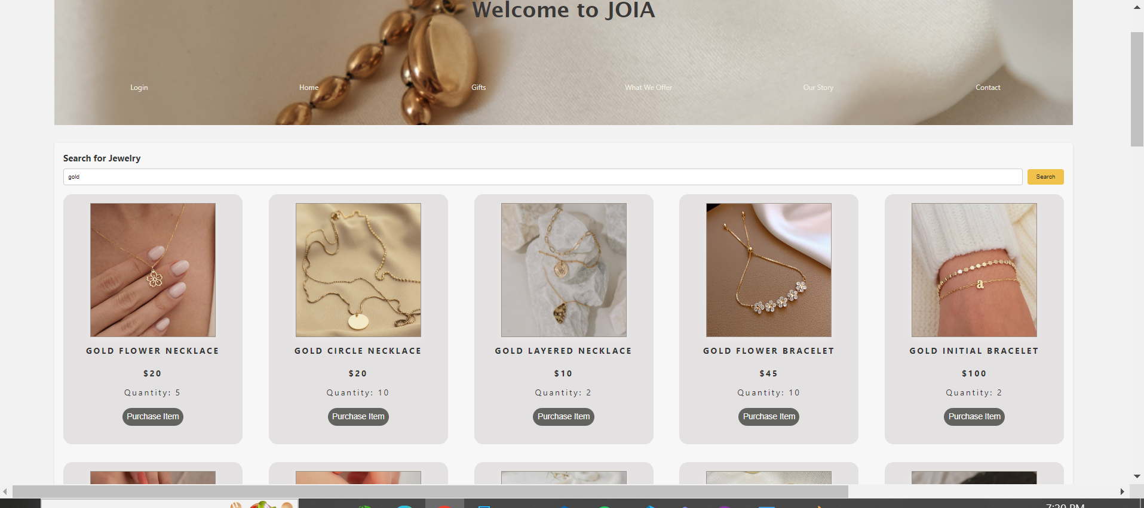

**More Done from our behalf:**

Able to purchase item after searching

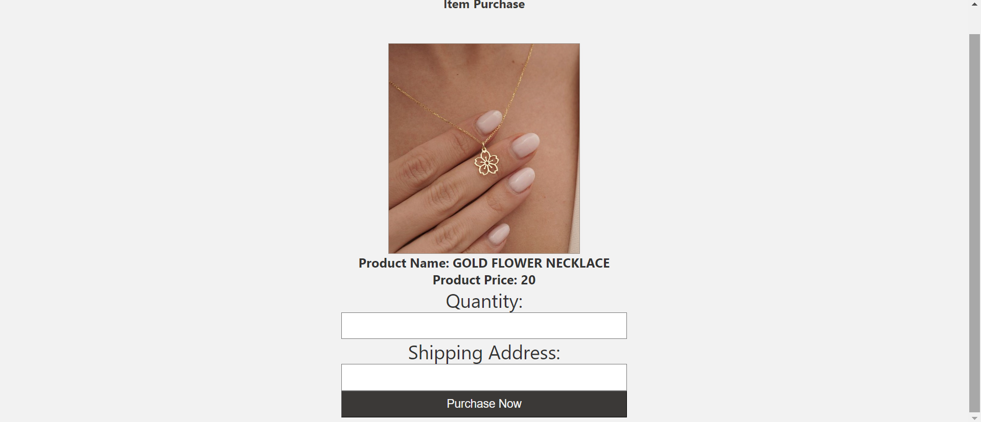

Use Case 2: Search available items in specific Categories.

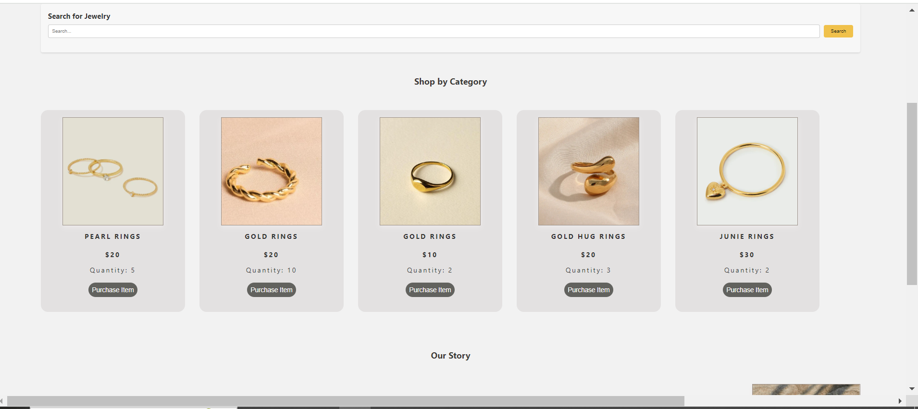

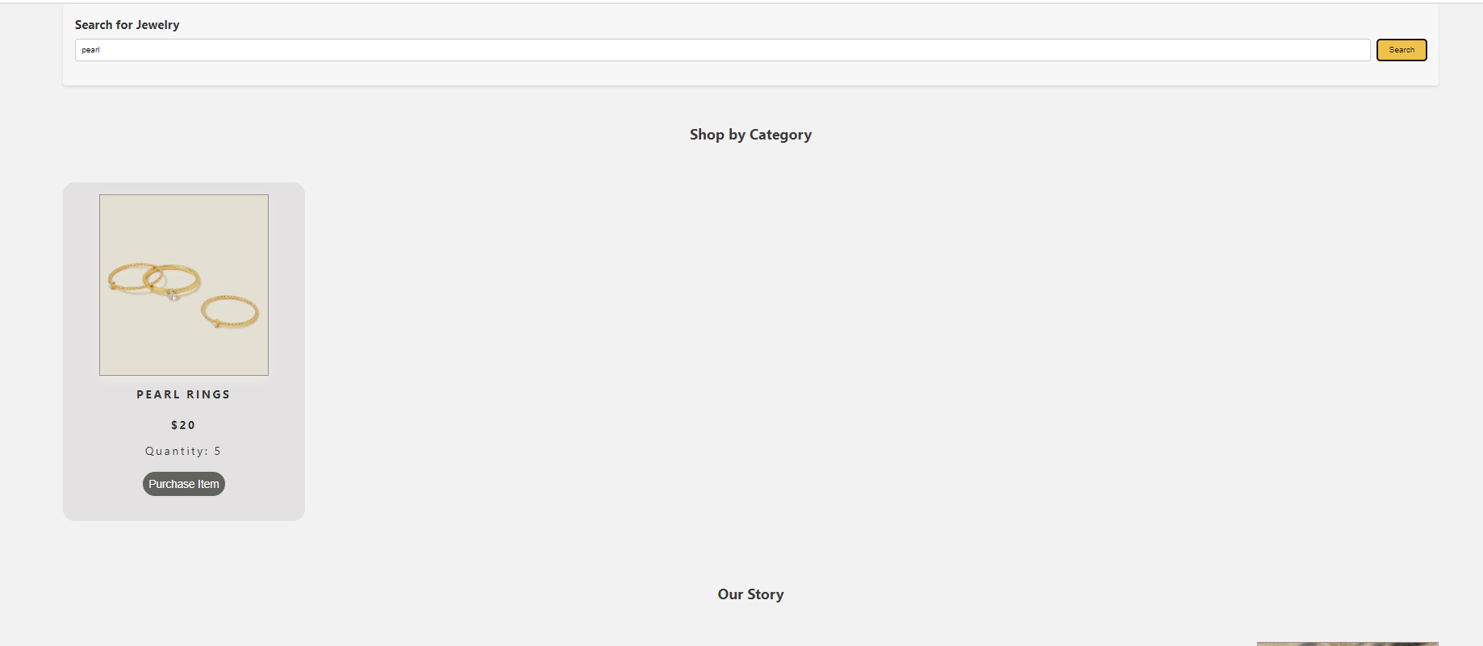

Use Case 3 and 4 : Purchase an item and view the purchase history

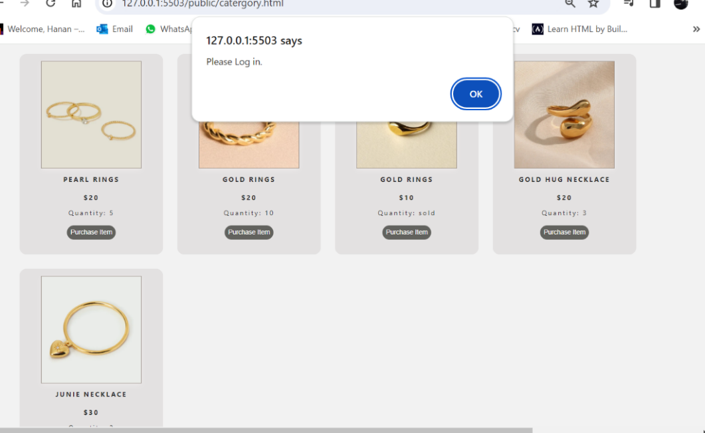

Try to purchase an item when customer is not logged in (it will fail)

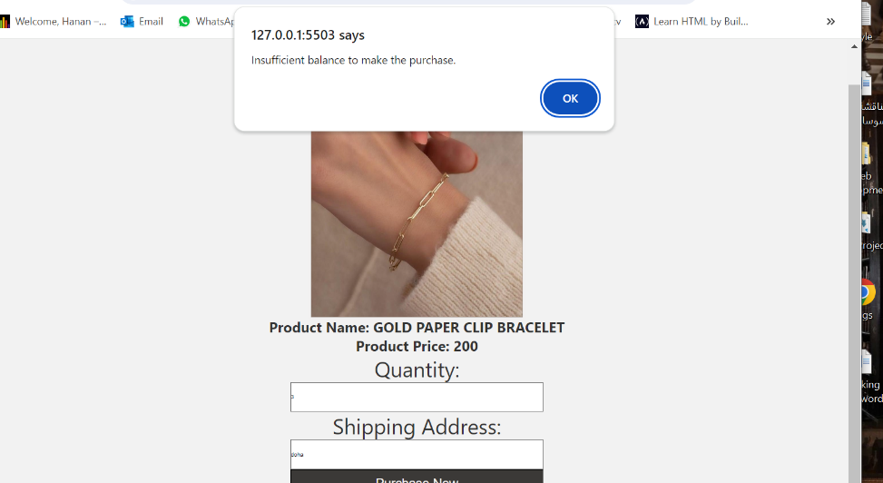

If the customer’s balance is not enough to purchase the item, he should not be able to purchase it

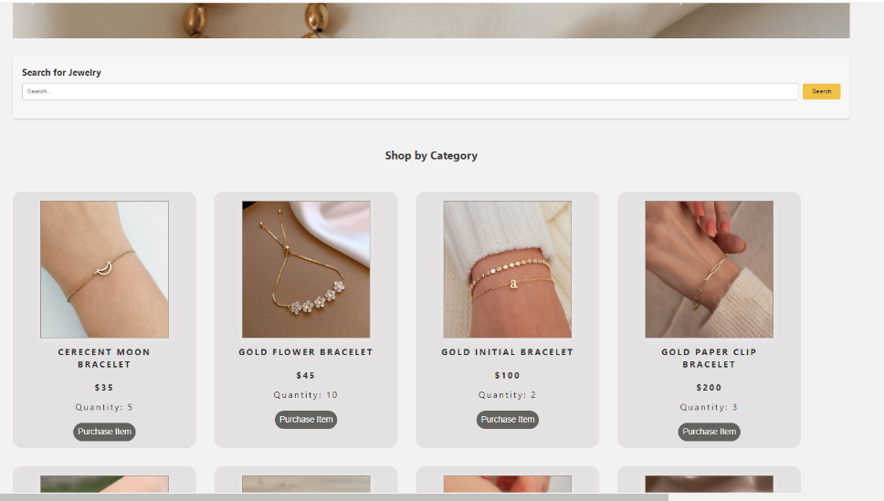

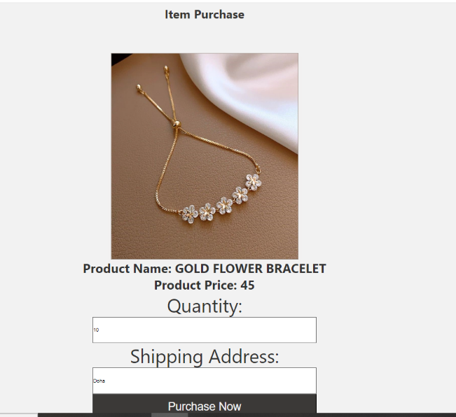

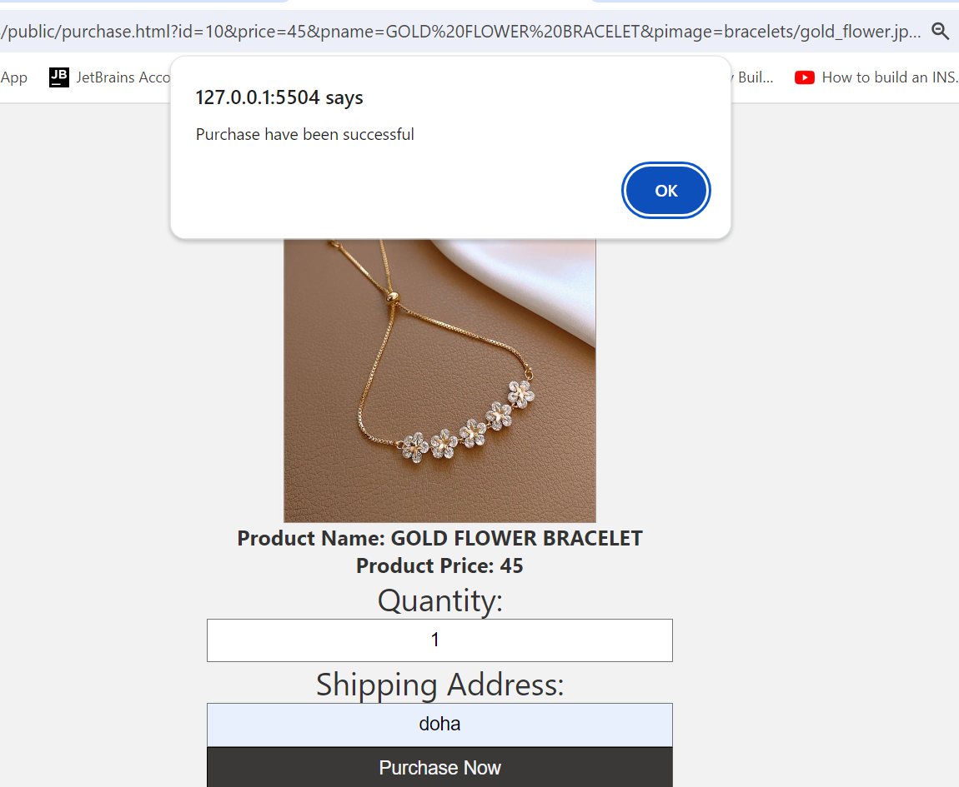

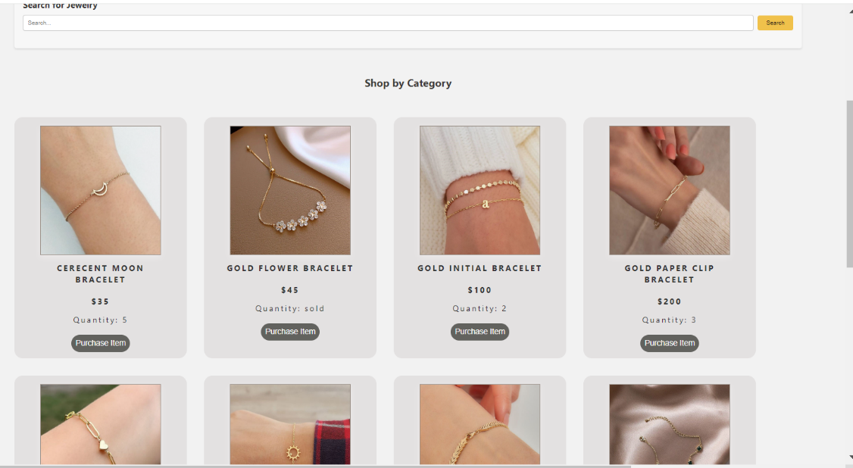

If the customer purchased the whole quantity, the item should be sold out and that should appear to the customer and the seller

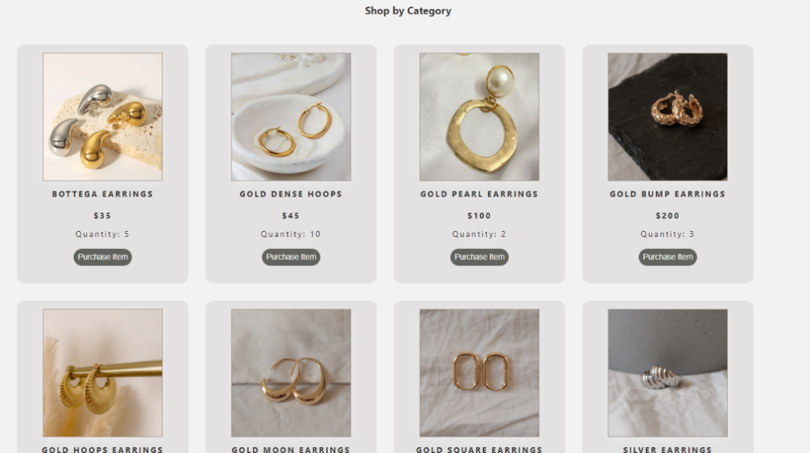

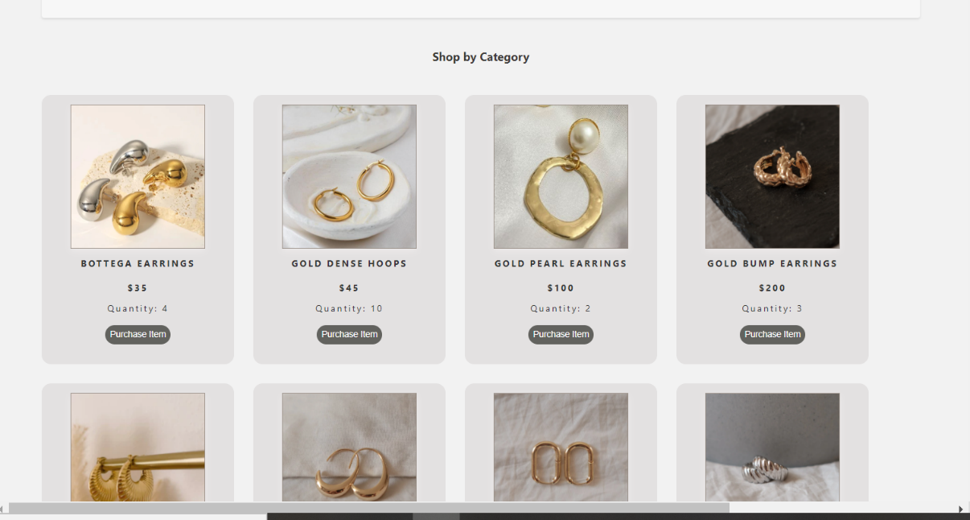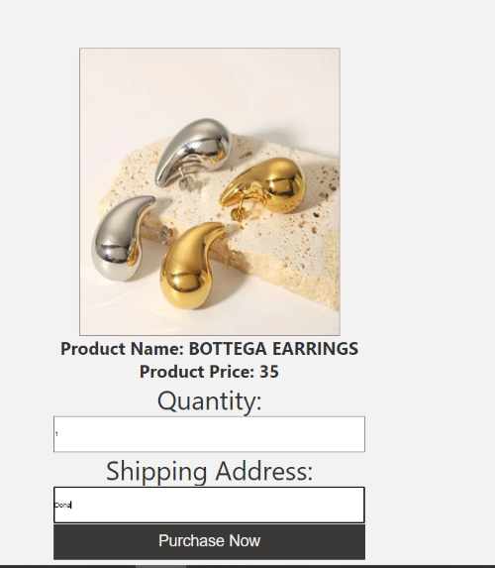

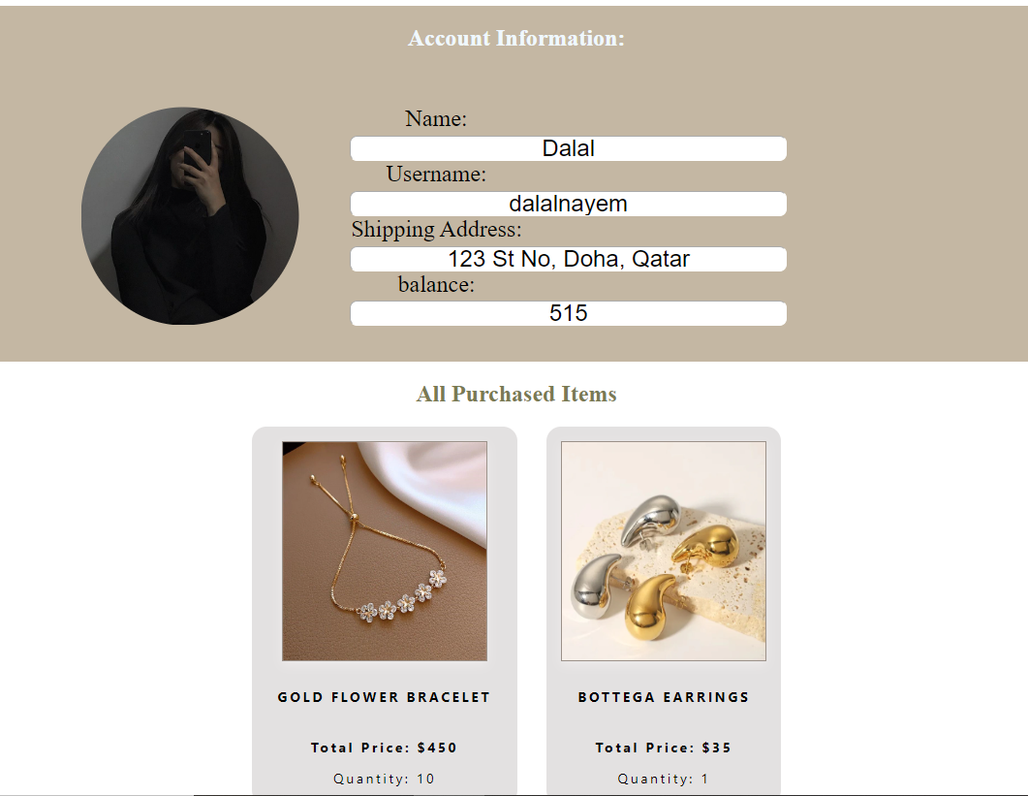

Item purchased successfully, the quantity of the item decreased and added to the purchase history of the customer

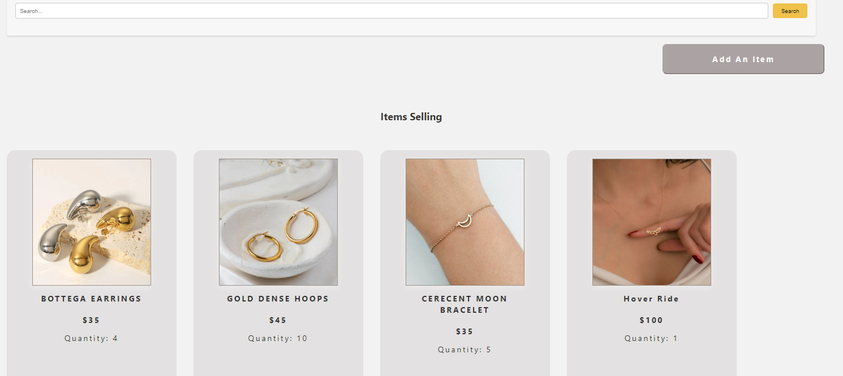Use Case 5 and 6: View available items on sale and sale history and upload an item to be sold

The seller can see the item has been purchased because the quantity decreased.

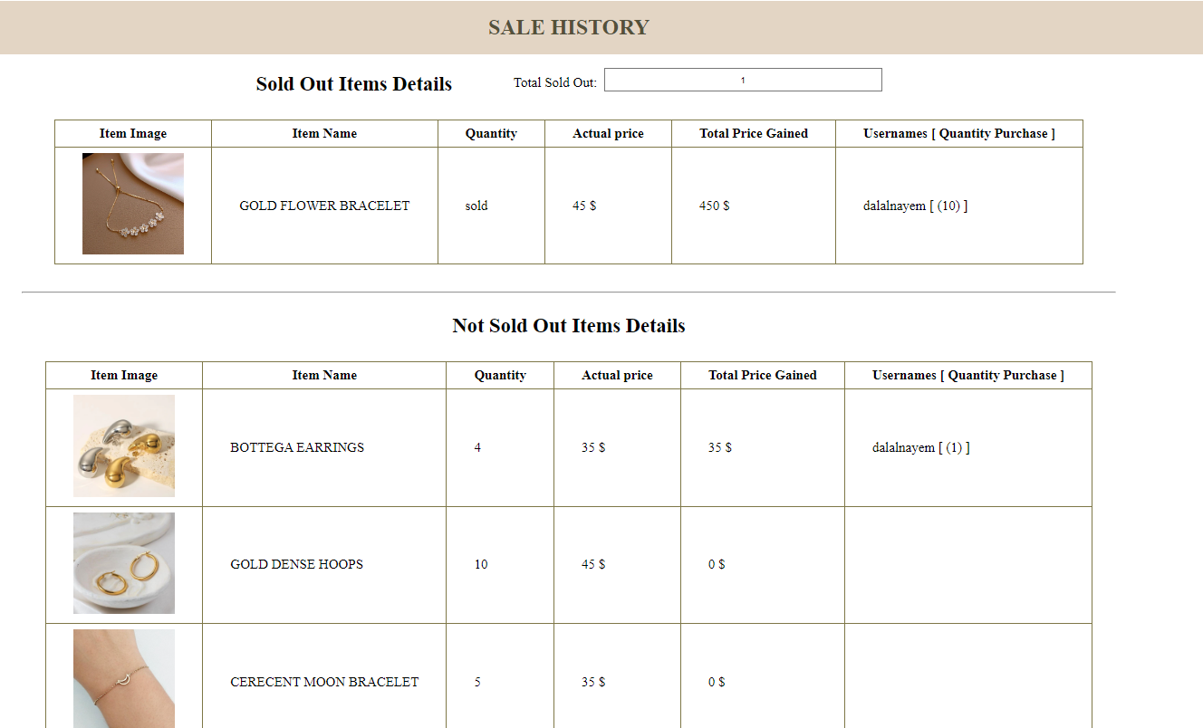

The seller can see in the sale history section how many items are sold, who bought it (username), and its selling price should appear.

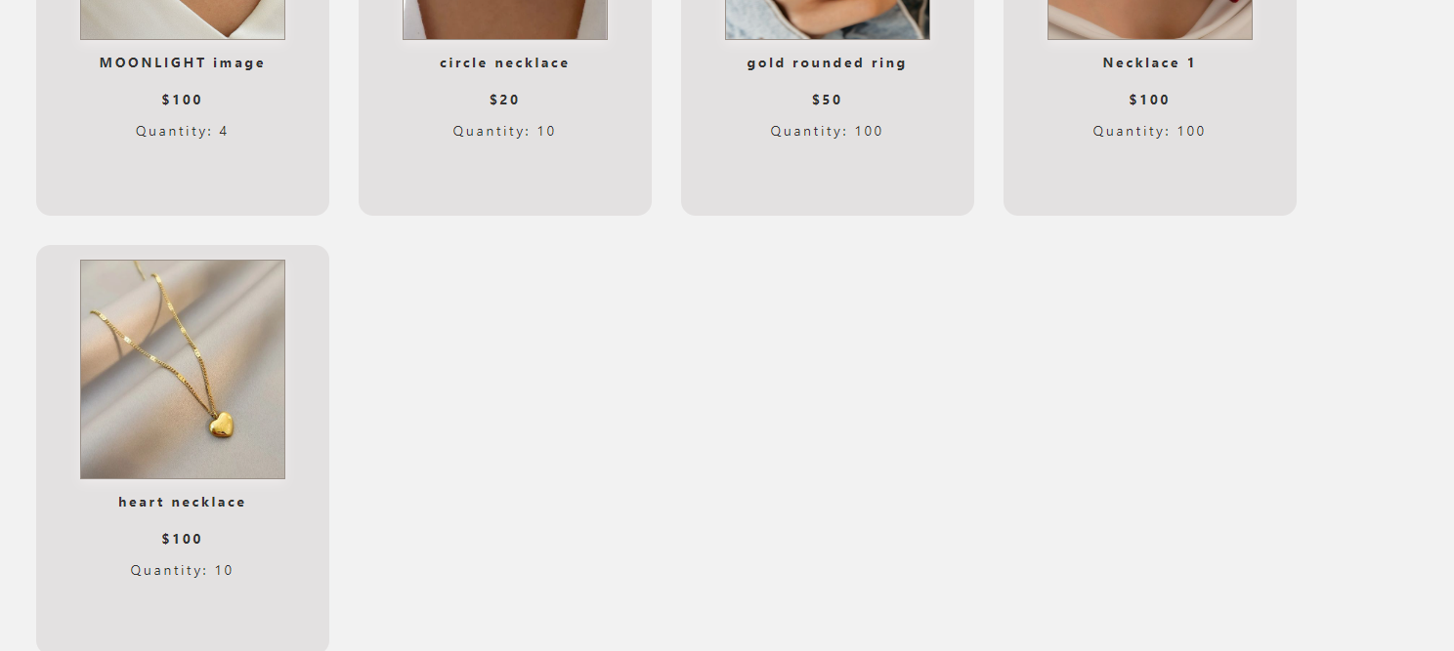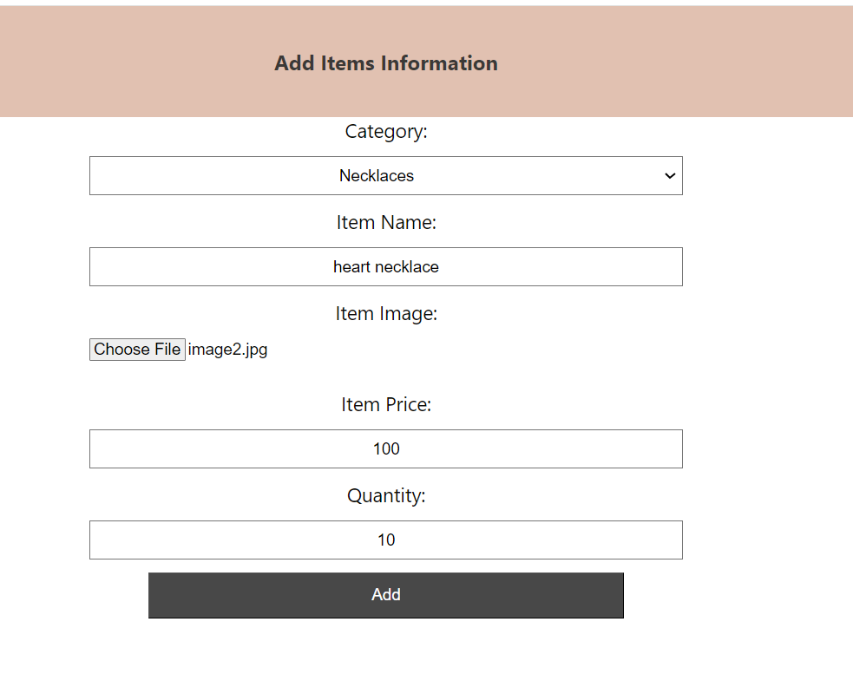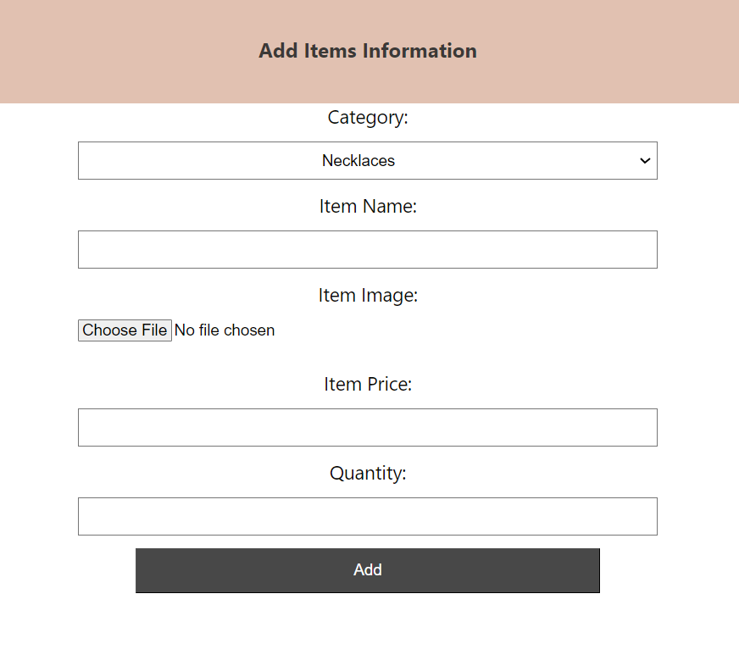

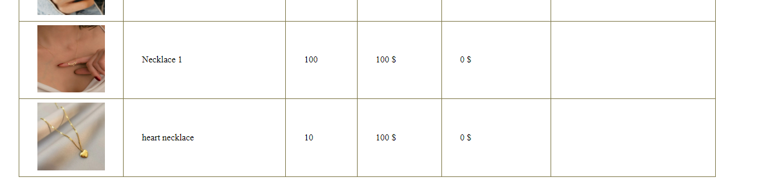

The seller can add a new item and check that the item has been displayed with the available items and added to the sales history.

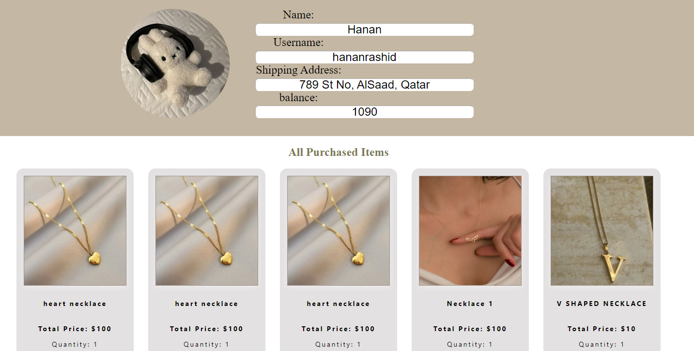

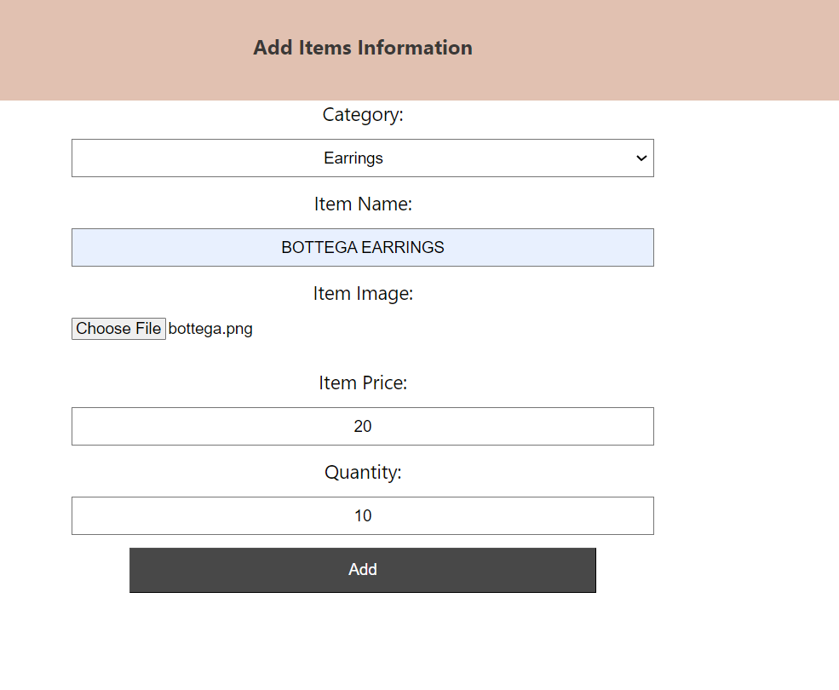A customer can purchase the new added item.

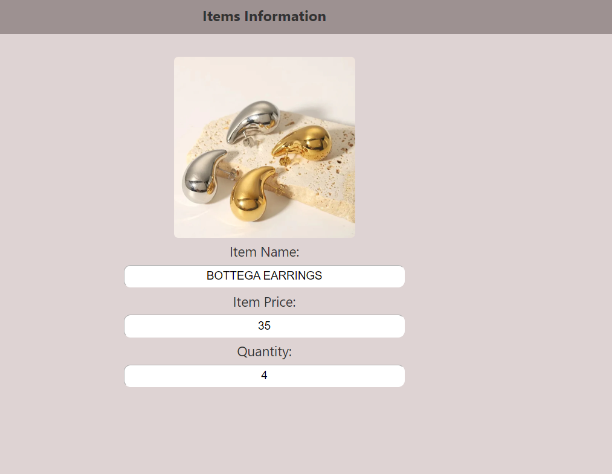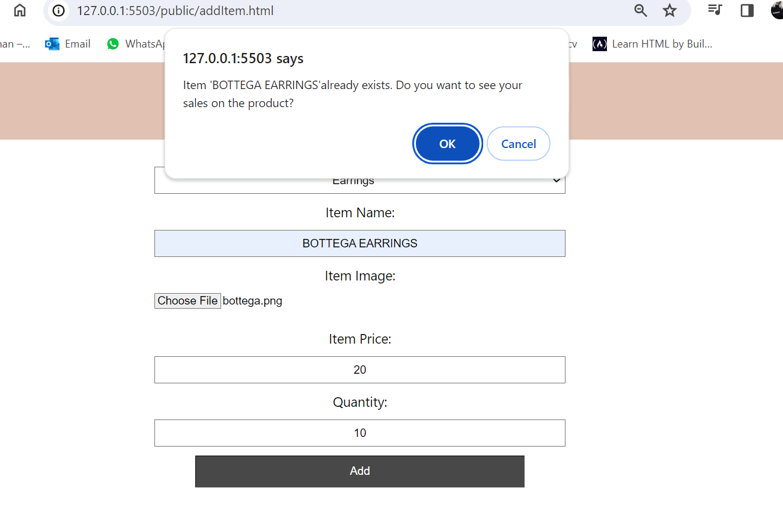

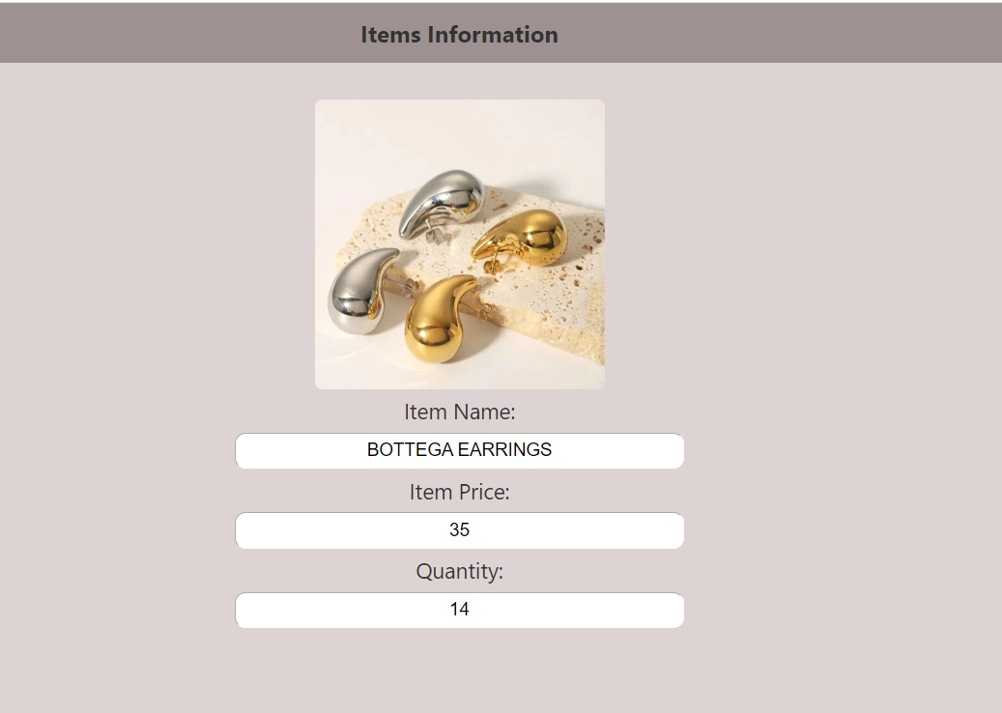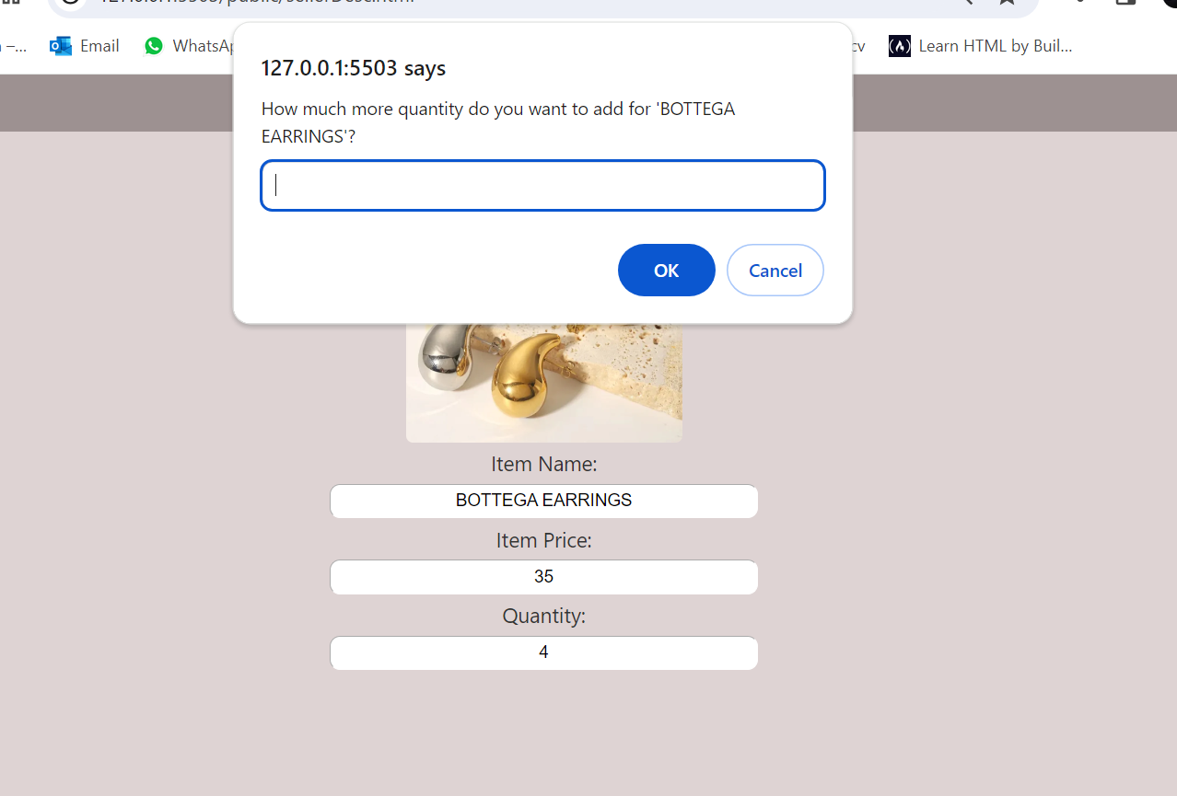

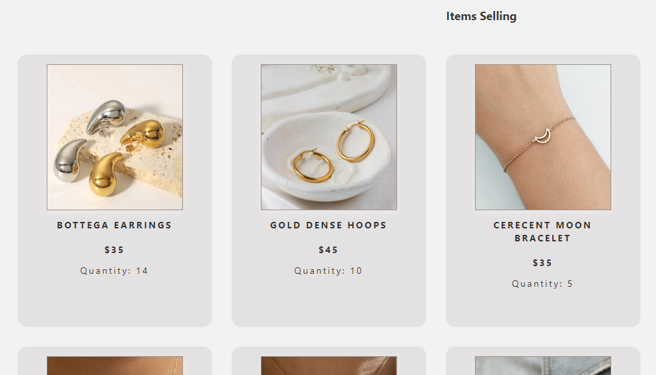

If the seller tries to add an item that is already available, he will not be able to do so, instead he will be asked to change the quantity if he wants, and if he changes the quantity, the new quantity will appear to the customer and seller.

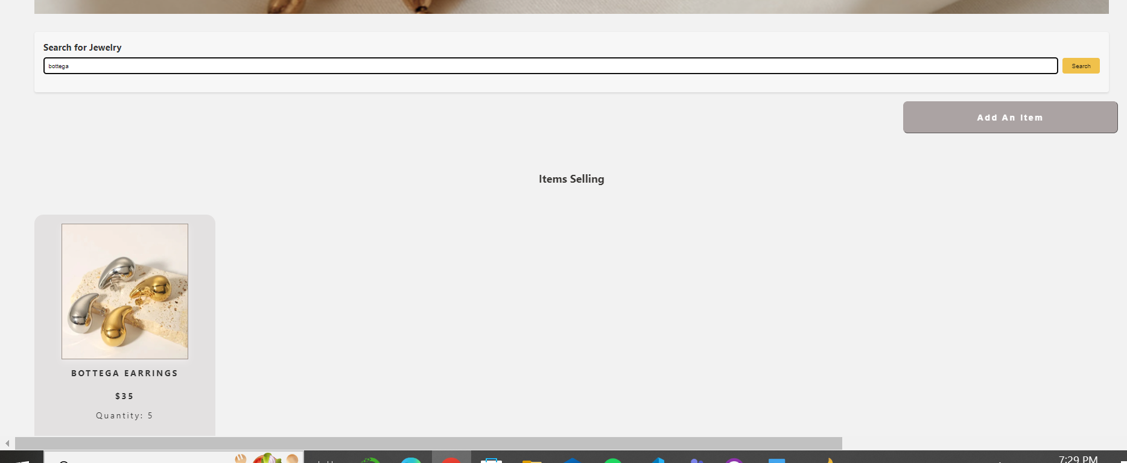

The item should start appearing in the search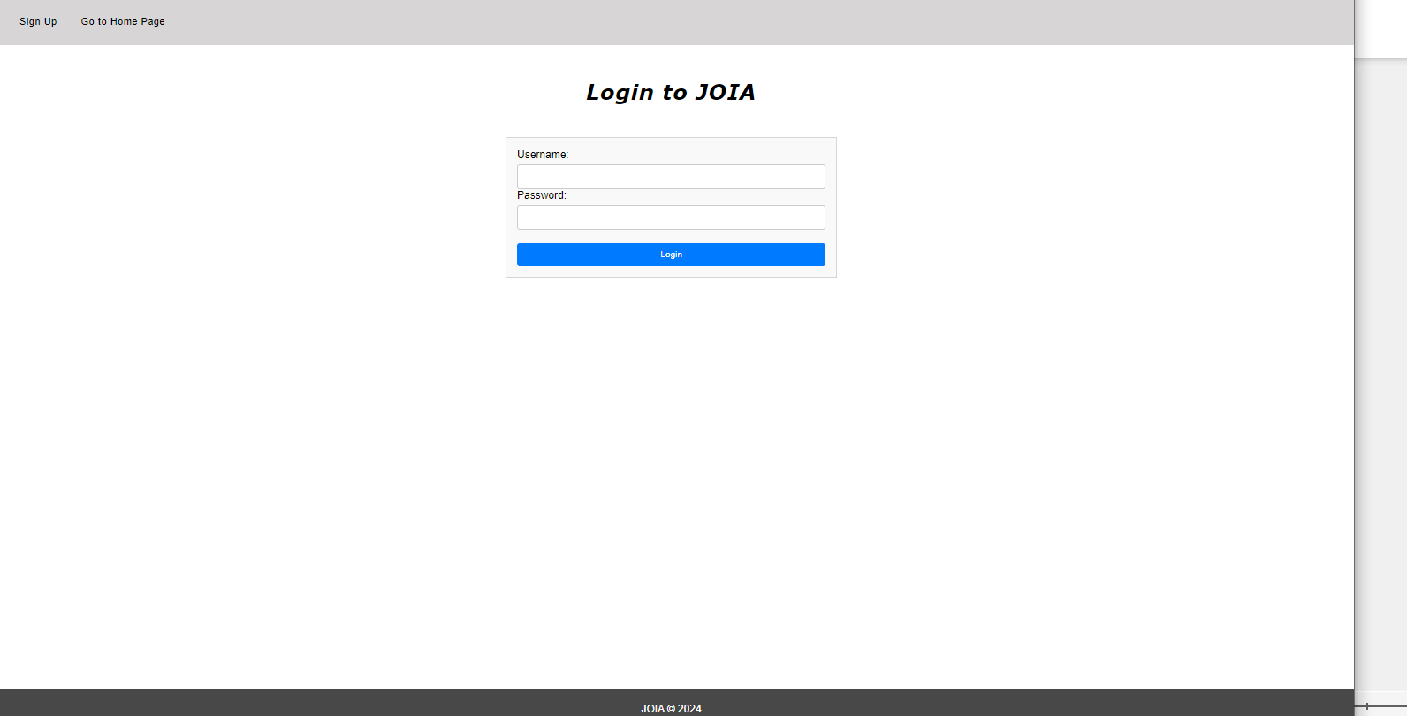

The user is logged out.